CLTMS – Methodology, Time Estimation, Case Study, PERT & Gantt
Community Learning & Training Management System (Courses & Enrollment) · MUFIC System Analysis Project
Prepared by: Yusuf Khalid Hassan Huessin Khalifa (يوسف خالد حسن حسين خليفه) · Section: Wednesday, 11 a.m.

1. Project Overview
CLTMS is a bilingual (Arabic/English), mobile-friendly web system that manages the courses of a community learning center and the enrollment of learners. Learners browse and search the course catalog, register and enroll online, and receive a confirmation. The system controls seats automatically, keeps a waiting list, records payments and receipts, tracks attendance and issues certificates. Staff and trainers manage courses, classes and learners from one place, and the manager gets enrollment, attendance and revenue reports on demand.
Stakeholders: learners, trainers, front-desk/registration staff, center manager, IT/maintenance.
Core modules: (1) Users & roles, (2) Course catalog & search, (3) Enrollment, seat control & waiting list, (4) Payments & receipts, (5) Attendance, (6) Certificates, (7) Reports & dashboard, (8) Bilingual UI (Arabic RTL / English LTR).

2. Methodology

2.1 Candidate methodologies compared
Criterion | Waterfall | Prototyping | RAD | Spiral | Agile (Scrum-lite)
Requirements stability needed | High | Low | Medium | Low | Low
Early user feedback | Late | Early | Early | Per loop | Every iteration
Fits small team | Yes | Yes | Yes | Heavy | Yes
Risk handling | Weak | Medium | Medium | Strong | Good (small increments)
Documentation (needed for a course) | Strong | Weak | Weak | Strong | Medium
Delivers usable parts early | No | Partly | Yes | Partly | Yes

2.2 Selected approach: Hybrid Iterative-Incremental SDLC (Waterfall-style analysis + Agile build)
The project uses a hybrid model: the analysis and design phases follow a structured SDLC (to produce the formal artifacts a system analysis project requires: feasibility study, system request, requirements, models), while the build phase is delivered in three short increments using Scrum-lite practices.
Why this fits CLTMS:
- Many user groups with different needs (learners, staff, trainers, manager) – requirements will be refined after seeing working screens.
- Small team – full Scrum ceremonies would be overhead; a light version (planning, short daily check-in, review, retrospective) is enough.
- Bilingual RTL/LTR interface is a known risk – it needs to be validated early, not at the end.
- Clear modular scope – the eight modules map naturally to increments.
- Course deliverables – the formal phases keep the required documentation complete.

2.3 Phases and deliverables
Phase | Activities | Main deliverables
1. Planning & Analysis | Feasibility study, system request, fact-finding (interviews, questionnaires, observation, document review), requirements specification | Feasibility & cost-benefit study, system request, SRS, use cases, prioritized backlog
2. Design | Process, data and object modeling; architecture; database; bilingual UI/UX | DFDs, ERD, UML (use case, class, sequence), DB schema, wireframes/prototype
3. Build (3 increments) | Increment 1: users, roles, catalog, search. Increment 2: enrollment, seat control, waiting list, payments, receipts, core UI. Increment 3: attendance, certificates, reports | Working, demonstrable software after each increment
4. Testing | Integration/system testing, security and usability testing, user acceptance testing (UAT) | Test plan & results, defect log, UAT sign-off
5. Deployment & Support | Documentation, staff/trainer training, go-live, handover | User manual, training session, deployed system

2.4 Techniques and practices
- Fact-finding: interviews with manager and staff, short questionnaire for learners, observation of the current registration desk, review of existing forms and registers.
- Prioritization (MoSCoW):
  - Must: roles & login, course catalog/search, online registration & enrollment, automatic seat control, payments & receipts, Arabic/English UI.
  - Should: waiting list with automatic promotion, attendance tracking, certificates.
  - Could: report export (PDF/Excel), email/SMS notifications.
  - Won't (this release): online payment-gateway integration, native mobile app.
- Modeling: use case diagrams and descriptions, DFD (context + level 0/1), ERD, class and sequence diagrams.
- Backlog & tracking: user stories in GitHub Issues, Kanban board (To Do / In Progress / Review / Done).
- Definition of Done: code reviewed, tested, works in both languages and on mobile, merged to main, documented.
- Version control: Git/GitHub with feature branches and pull requests.
- Quality assurance: unit tests for seat-control and payment logic, test cases traced to requirements, UAT with real staff.
- Change control: new requests are logged, impact-assessed (time/cost/risk) and only accepted at the next increment boundary.

2.5 Roles
Role | Responsibility
Project manager / analyst | Planning, requirements, models, documentation, risk and change control
Developer(s) | Database, back-end, front-end implementation
UI/UX designer | Wireframes, bilingual/RTL design, usability checks
Tester / QA | Test plan, execution, defect tracking
Client representative (center manager) | Approves requirements, reviews increments, signs off UAT
One person can hold several roles in a small team; effort stays the same, duration may extend (see Section 3.5).

2.6 Key risks and responses
Risk | Likelihood | Impact | Response
Scope creep (extra features requested) | High | High | MoSCoW list, change control, fixed increments
Overbooking when two learners enroll for the last seat at once | Medium | High | Database transactions/locking, automated tests for concurrent enrollment
Arabic RTL layout and translation defects | Medium | Medium | Bilingual design from first wireframe, i18n framework, native-speaker review
Payment/receipt inaccuracies | Low | High | Single source of truth for payments, audit log, reconciliation report
Learner personal data exposure | Low | High | Role-based access, hashed passwords, HTTPS, minimal data collected
Low staff adoption | Medium | Medium | Involve staff in UAT, short training, simple UI

3. Time Estimation

3.1 Method
A bottom-up estimate was built from a Work Breakdown Structure (WBS) of 15 activities. Each activity uses a three-point estimate in working days:
- O = optimistic, M = most likely, P = pessimistic
- Expected time: te = (O + 4M + P) / 6
- Variance: σ² = ((P − O) / 6)²
Assumptions: 5 working days per week (Sunday–Thursday); a small team of up to three people working in parallel where the plan allows; each module activity includes its own back-end logic and testing; durations are elapsed working days.

3.2 Activity list, dependencies and estimates
ID | Activity | Predecessors | O | M | P | te (days) | σ²
A | Planning & requirements elicitation | – | 3 | 5 | 9 | 5.33 | 1.00
B | Requirements analysis & specification (SRS, use cases) | A | 4 | 6 | 10 | 6.33 | 1.00
C | System modeling (DFD, ERD, UML) | B | 4 | 6 | 9 | 6.17 | 0.69
D | Database design & setup | C | 3 | 4 | 7 | 4.33 | 0.44
E | UI/UX design (bilingual wireframes & prototype) | B | 4 | 6 | 10 | 6.33 | 1.00
F | Architecture & technical design | C | 2 | 3 | 5 | 3.17 | 0.25
G | Users, roles & course catalog/search (back-end) | D, F | 5 | 8 | 12 | 8.17 | 1.36
H | Enrollment, seat control & waiting list | G | 5 | 8 | 13 | 8.33 | 1.78
I | Payments & receipts | G | 4 | 6 | 10 | 6.33 | 1.00
J | Attendance & certificates | H | 4 | 6 | 9 | 6.17 | 0.69
K | Front-end implementation (pages, Arabic/English, responsive) | E, G | 6 | 9 | 14 | 9.33 | 1.78
L | Reports & manager dashboard | H, I | 3 | 5 | 8 | 5.17 | 0.69
M | Integration & system testing | J, K, L | 5 | 7 | 11 | 7.33 | 1.00
N | User acceptance testing & fixes | M | 3 | 4 | 7 | 4.33 | 0.44
O | Documentation, training & deployment | N | 3 | 4 | 6 | 4.17 | 0.25

3.3 Effort summary
Phase group | Activities | Effort (person-days) | Share
Analysis & design | A–F | 31.7 | 35%
Build | G–L | 43.5 | 48%
Testing & deployment | M–O | 15.8 | 17%
Total |  | 91.0 | 100%

3.4 Result
- Expected project duration (critical path): 60.67 working days ≈ 12.1 weeks.
- Total effort: 91 person-days; at most three activities run in parallel, so a team of three can follow this schedule.
- Critical-path variance: 8.67, so the standard deviation σ ≈ 2.94 days.
Target finish | Probability of completing on time
60.7 days (12.1 weeks) | 50%
64 days (12.8 weeks) | ≈ 87%
65.5 days (13.1 weeks) | ≈ 95%
Recommendation: commit to 13 weeks, and keep 1 extra week as a management buffer (14 weeks total) for requirement changes and UAT fixes.

3.5 If the work is done by one person
Parallel activities then run one after another, so duration approaches the total effort: about 91 working days (≈ 18 weeks) at full-time pace, longer if the work is part-time.

4. Case Study
The center and figures below are an illustrative scenario created to demonstrate the analysis; replace them with real data collected from your target center and your Feasibility & Cost-Benefit sheet.

4.1 Background
Al-Amal Community Learning Center is a non-profit center in a mid-sized Egyptian city offering about 30 courses per term (languages, computer skills, handicrafts, exam preparation) to around 900 learners, with 12 part-time trainers and 3 administrative staff. Courses are announced on social media and by posters.

4.2 Current situation and problems
Area | Current practice | Resulting problem
Registration | Paper forms at the front desk during office hours | Long queues, working learners and women with caregiving duties cannot attend in person
Seat control | Counted by hand in a notebook | Classes overbooked or half-empty; no fair waiting list
Payments | Cash, handwritten receipts | Lost receipts, disputes, difficult month-end reconciliation
Attendance | Paper sheets kept by trainers | Sheets lost; certificate eligibility decided by memory
Certificates | Typed manually in Word | Slow, spelling mistakes in names, no verification
Reporting | Manager asks staff to count by hand | Reports take days, figures inconsistent
Language | Mixed Arabic/English forms | Confusion for learners and staff

4.3 Requirements derived from the problems
- Online catalog with search by name and category (Arabic and English).
- Online registration and enrollment with instant confirmation.
- Automatic seat control and a waiting list with automatic promotion when a seat opens.
- Payment recording with printable/digital receipts.
- Attendance recording per class session and attendance-rate calculation.
- Automatic certificate generation for learners who meet the attendance rule.
- Role-based access (learner, trainer, staff, manager).
- On-demand enrollment, attendance and revenue reports.

4.4 Proposed solution
CLTMS replaces paper processes with one web system. Learners self-register from a phone; staff handle walk-ins and payments through the same screens; trainers mark attendance in class; the manager opens a dashboard instead of requesting manual counts. The project follows the hybrid methodology in Section 2 and the schedule in Sections 5–6.

4.5 Expected benefits (illustrative targets)
Indicator | Before | Target after CLTMS
Time to register one learner | ≈ 10–15 min at desk | ≈ 3 min online
Overbooked classes per term | Several | 0
Receipt disputes per term | Frequent | Near 0 (every payment recorded)
Time to produce enrollment/revenue report | 2–3 days | Under 1 minute
Time to issue a certificate | ≈ 10 min each | Automatic

4.6 Lessons and success factors
- Involve front-desk staff early – they own the daily process and decide adoption.
- Test seat control under concurrent enrollment; this is the most visible failure if wrong.
- Design Arabic RTL screens from the start, not as a translation at the end.
- Keep scope disciplined: gateway payments and a native app are future releases.
- Run a short training and a parallel run (paper + system) for the first weeks after go-live.

5. PERT Chart

5.1 Network analysis (times in working days)
ID | te | ES | EF | LS | LF | Slack | Critical?
A | 5.33 | 0.00 | 5.33 | 0.00 | 5.33 | 0.00 | Yes
B | 6.33 | 5.33 | 11.67 | 5.33 | 11.67 | 0.00 | Yes
C | 6.17 | 11.67 | 17.83 | 11.67 | 17.83 | 0.00 | Yes
D | 4.33 | 17.83 | 22.17 | 17.83 | 22.17 | 0.00 | Yes
E | 6.33 | 11.67 | 18.00 | 29.17 | 35.50 | 17.50 | No
F | 3.17 | 17.83 | 21.00 | 19.00 | 22.17 | 1.17 | No
G | 8.17 | 22.17 | 30.33 | 22.17 | 30.33 | 0.00 | Yes
H | 8.33 | 30.33 | 38.67 | 30.33 | 38.67 | 0.00 | Yes
I | 6.33 | 30.33 | 36.67 | 33.33 | 39.67 | 3.00 | No
J | 6.17 | 38.67 | 44.83 | 38.67 | 44.83 | 0.00 | Yes
K | 9.33 | 30.33 | 39.67 | 35.50 | 44.83 | 5.17 | No
L | 5.17 | 38.67 | 43.83 | 39.67 | 44.83 | 1.00 | No
M | 7.33 | 44.83 | 52.17 | 44.83 | 52.17 | 0.00 | Yes
N | 4.33 | 52.17 | 56.50 | 52.17 | 56.50 | 0.00 | Yes
O | 4.17 | 56.50 | 60.67 | 56.50 | 60.67 | 0.00 | Yes
ES/EF = earliest start/finish; LS/LF = latest start/finish; Slack = LS − ES.

5.2 Critical path
A → B → C → D → G → H → J → M → N → O = 60.67 working days.
Any delay on these ten activities delays the whole project. Near-critical activities to watch: L (1.0 day slack) and F (1.17 days slack); I has 3 days, K has 5.17 days, and E has 17.5 days of slack.

5.3 Network diagram
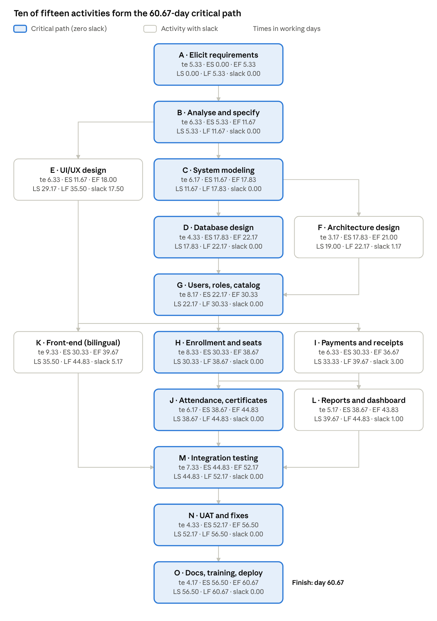
PERT network · 15 activities, critical path highlighted
The middle column is the critical path; the side boxes can slip by their slack without moving the finish date.

6. Gantt Chart
Project week 1 starts on the project start date; each week = 5 working days (Sunday–Thursday). ■ = critical-path activity, □ = non-critical activity (has slack).
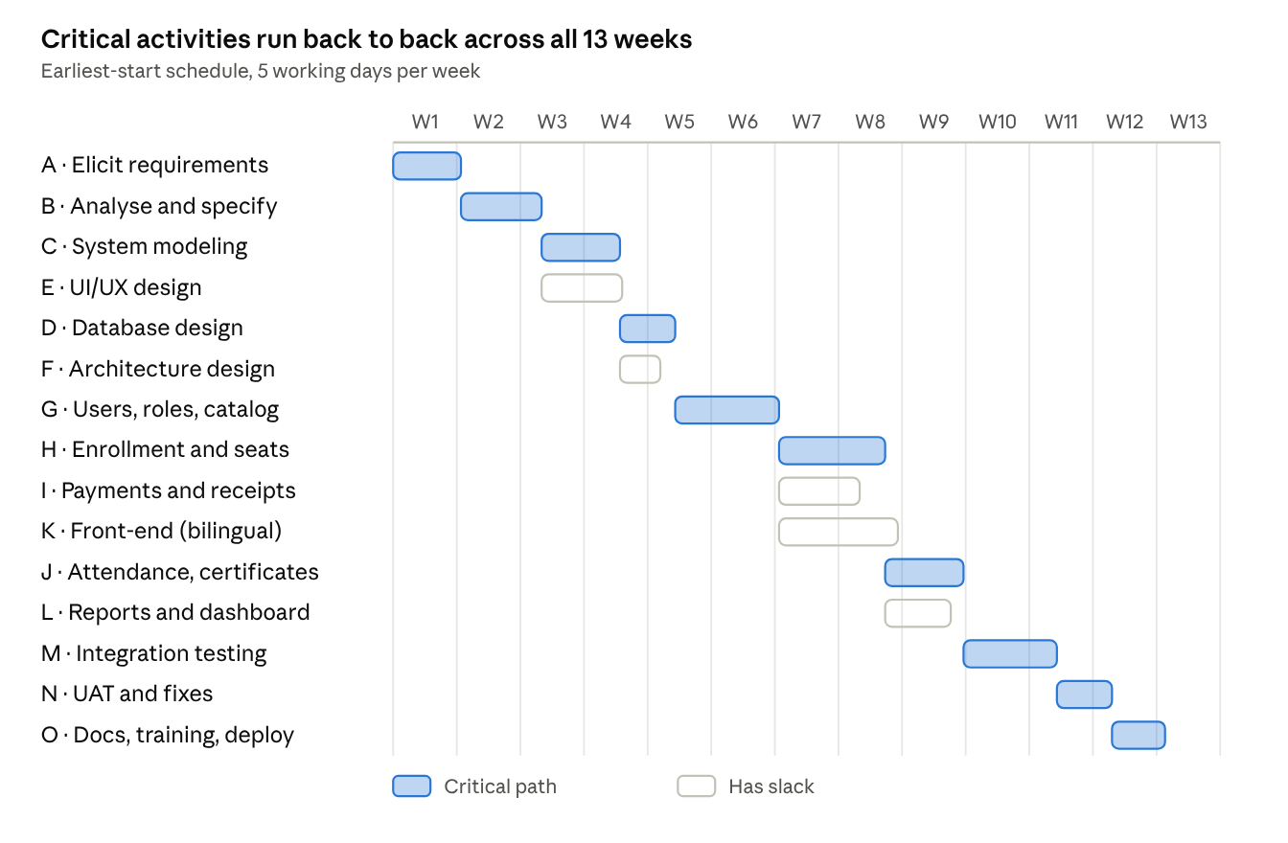
Gantt chart · 13 weeks, 15 activities
Filled bars are critical activities, outlined bars have slack. The table below lists the exact start and end days.
ID | Activity | Start day | End day | W1 | W2 | W3 | W4 | W5 | W6 | W7 | W8 | W9 | W10 | W11 | W12 | W13
A | Planning & elicitation | 0 | 5.3 | ■ | ■
B | Requirements analysis | 5.3 | 11.7 |  | ■ | ■
C | System modeling | 11.7 | 17.8 |  |  | ■ | ■
E | UI/UX design | 11.7 | 18.0 |  |  | □ | □
D | Database design & setup | 17.8 | 22.2 |  |  |  | ■ | ■
F | Architecture design | 17.8 | 21.0 |  |  |  | □ | □
G | Users, roles & catalog | 22.2 | 30.3 |  |  |  |  | ■ | ■ | ■
H | Enrollment, seats, waiting list | 30.3 | 38.7 |  |  |  |  |  |  | ■ | ■
I | Payments & receipts | 30.3 | 36.7 |  |  |  |  |  |  | □ | □
K | Front-end implementation | 30.3 | 39.7 |  |  |  |  |  |  | □ | □
J | Attendance & certificates | 38.7 | 44.8 |  |  |  |  |  |  |  | ■ | ■
L | Reports & dashboard | 38.7 | 43.8 |  |  |  |  |  |  |  | □ | □
M | Integration & system testing | 44.8 | 52.2 |  |  |  |  |  |  |  |  | ■ | ■ | ■
N | UAT & fixes | 52.2 | 56.5 |  |  |  |  |  |  |  |  |  |  | ■ | ■
O | Documentation, training & deployment | 56.5 | 60.7 |  |  |  |  |  |  |  |  |  |  |  | ■ | ■

Milestones
Milestone | Target (day / week)
M1 – Requirements baseline approved | Day 11.7 / end of week 3
M2 – Design complete (models, DB, UI prototype) | Day 22.2 / week 5
M3 – Increment 1 done (users, roles, catalog) | Day 30.3 / week 7
M4 – Increment 2 done (enrollment, payments, UI) | Day 39.7 / week 8
M5 – Increment 3 done (attendance, certificates, reports) | Day 44.8 / week 9
M6 – UAT sign-off | Day 56.5 / week 12
M7 – Go-live and handover | Day 60.7 / week 13

